Chapter 8

8.1: Organizational Culture

  - 8: Organizational Culture

  - 8.2: Case in Point: Google Creates Unique Culture
- picture_as_pdf
Downloads
Buy Print Copy
Review / Adopt
View on CommonsDonate
- 
- Anonymous
- LibreTexts
Figure 8.1.1: Just as water is invisible to the fish swimming in it, yet affects their actions, culture consists of unseen elements such as assumptions and values that affect organizational life. Alexandru Stoian – School of fish – CC BY-NC-ND 2.0.

What’s in It for Me?
Reading this chapter will help you do the following:
- Describe what organizational culture is and why it is important for an organization.
- Understand the dimensions that make up a company’s culture.
- Understand the creation and maintenance of organizational culture.
- Understand the factors that create cultural change.
- Develop personal culture management skills.
Organizations, just like individuals, have their own personalities—more typically known as organizational cultures. Understanding how culture is created, communicated, and changed will help you to be a more effective manager. But first, let’s define organizational culture.
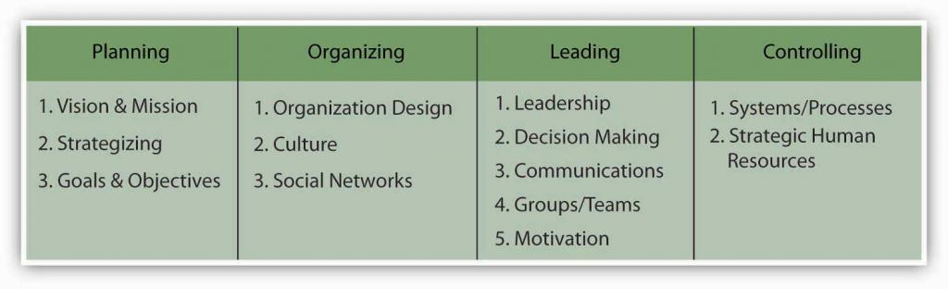8.1.2 The P-O-L-C Framework

8.2: Case in Point: Google Creates Unique Culture

  - 8.1: Organizational Culture

  - 8.3: Understanding Organizational Culture
- picture_as_pdf
Downloads
Buy Print Copy
Review / Adopt
View on CommonsDonate
- Anonymous
- LibreTexts
Figure 8.2.1: Google road sign in front of a site
Google (NASDAQ: GOOG) is one of the best-known and most admired companies around the world, so much so that “googling” is the term many use to refer to searching information on the Web. What started out as a student project by two Stanford University graduates—Larry Page and Sergey Brin—in 1996, Google became the most frequently used Web search engine on the Internet with 1 billion searches per day in 2009, as well as other innovative applications such as Gmail, Google Earth, Google Maps, and Picasa. Google grew from 10 employees working in a garage in Palo Alto to 10,000 employees operating around the world by 2009. What is the formula behind this success?
Google strives to operate based on solid principles that may be traced back to its founders. In a world crowded with search engines, they were probably the first company that put users first. Their mission statement summarizes their commitment to end-user needs: “To organize the world’s information and to make it universally accessible and useful.” While other companies were focused on marketing their sites and increasing advertising revenues, Google stripped the search page of all distractions and presented users with a blank page consisting only of a company logo and a search box. Google resisted pop-up advertising, because the company felt that it was annoying to end-users. They insisted that all their advertisements would be clearly marked as “sponsored links.” This emphasis on improving user experience and always putting it before making more money in the short term seems to have been critical to their success.
Keeping their employees happy is also a value they take to heart. Google created a unique work environment that attracts, motivates, and retains the best players in the field. Google was ranked as the number 1 “Best Place to Work For” by Fortune magazine in 2007 and number 4 in 2010. This is not surprising if one looks closer to how Google treats employees. On their Mountain View, California, campus called the “Googleplex,” employees are treated to free gourmet food options including sushi bars and espresso stations. In fact, many employees complain that once they started working for Google, they tend to gain 10 to 15 pounds! Employees have access to gyms, shower facilities, video games, on-site child care, and doctors. Google provides 4 months of paternal leave with 75% of full pay and offers $500 for take-out meals for families with a newborn. These perks create a place where employees feel that they are treated well and their needs are taken care of. Moreover, they contribute to the feeling that they are working at a unique and cool place that is different from everywhere else they may have worked.
In addition, Google encourages employee risk taking and innovation. How is this done? When a vice president in charge of the company’s advertising system made a mistake costing the company millions of dollars and apologized for the mistake, she was commended by Larry Page, who congratulated her for making the mistake and noting that he would rather run a company where they are moving quickly and doing too much, as opposed to being too cautious and doing too little. This attitude toward acting fast and accepting the cost of resulting mistakes as a natural consequence of working on the cutting edge may explain why the company is performing much ahead of competitors such as Microsoft and Yahoo! One of the current challenges for Google is to expand to new fields outside of their Web search engine business. To promote new ideas, Google encourages all engineers to spend 20% of their time working on their own ideas.
Google’s culture is reflected in their decision making as well. Decisions at Google are made in teams. Even the company management is in the hands of a triad: Larry Page and Sergey Brin hired Eric Schmidt to act as the CEO of the company, and they are reportedly leading the company by consensus. In other words, this is not a company where decisions are made by the senior person in charge and then implemented top down. It is common for several small teams to attack each problem and for employees to try to influence each other using rational persuasion and data. Gut feeling has little impact on how decisions are made. In some meetings, people reportedly are not allowed to say “I think…” but instead must say “the data suggest….” To facilitate teamwork, employees work in open office environments where private offices are assigned only to a select few. Even Kai-Fu Lee, the famous employee whose defection from Microsoft was the target of a lawsuit, did not get his own office and shared a cubicle with two other employees.
How do they maintain these unique values? In a company emphasizing hiring the smartest people, it is very likely that they will attract big egos that may be difficult to work with. Google realizes that its strength comes from its “small company” values that emphasize risk taking, agility, and cooperation. Therefore, they take their hiring process very seriously. Hiring is extremely competitive and getting to work at Google is not unlike applying to a college. Candidates may be asked to write essays about how they will perform their future jobs. Recently, they targeted potential new employees using billboards featuring brain teasers directing potential candidates to a Web site where they were subjected to more brain teasers. Each candidate may be interviewed by as many as eight people on several occasions. Through this scrutiny, they are trying to select “Googley” employees who will share the company’s values, perform at high levels, and be liked by others within the company.
Will this culture survive in the long run? It may be too early to tell, given that the company was only founded in 1998. The founders emphasized that their initial public offering (IPO) would not change their culture and they would not introduce more rules or change the way things are done in Google to please Wall Street. But can a public corporation really act like a start-up? Can a global giant facing scrutiny on issues including privacy, copyright, and censorship maintain its culture rooted in its days in a Palo Alto garage? Larry Page is quoted as saying, “We have a mantra: don’t be evil, which is to do the best things we know how for our users, for our customers, for everyone. So I think if we were known for that, it would be a wonderful thing.”
Case written by information from Elgin, B., Hof, R. D., & Greene, J. (2005, August 8). Revenge of the nerds—again. BusinessWeek. Retrieved April 30, 2010, from www.businessweek.com/technology/content/jul2005/tc20050728_5127_tc024.htm;
Hardy, Q. (2005, November 14). Google thinks small. Forbes, 176(10); Lashinky, A. (2006, October 2). Chaos by design. Fortune, 154(7); Mangalindan, M. (2004, March 29).
The grownup at Google: How Eric Schmidt imposed better management tactics but didn’t stifle search giant. Wall Street Journal, p. B1; Lohr, S. (2005, December 5). At Google, cube culture has new rules. New York Times. Retrieved April 30, 2010, from www.nytimes.com/2005/12/05/technology/05google.html;
Schoeneman, D. (2006, December 31). Can Google come out to play? New York Times. Retrieved April 30, 2010, from www.nytimes.com/2006/12/31/fashion/31google.html; Warner, M. (2004, June). What your company can learn from Google. Business 2.0, 5(5).

Discussion Questions
- Culture is an essential element of organizing in the P-O-L-C framework. Do you think Google has a strong culture? What would it take to make changes in that culture, for better or for worse?
- Do you think Google’s unique culture will help or hurt Google in the long run?
- What are the factors responsible for the specific culture that exists in Google?
- What type of decision-making approach has Google taken? Do you think this will remain the same over time? Why or why not?
- Do you see any challenges Google may face in the future because of its emphasis on having a risk-taking culture?

8.3: Understanding Organizational Culture

  - 8.2: Case in Point: Google Creates Unique Culture

  - 8.4: Measuring Organizational Culture
- picture_as_pdf
Downloads
Buy Print Copy
Review / Adopt
View on CommonsDonate
- Anonymous
- LibreTexts

Learning Objectives
- Define organizational culture.
- Understand why organizational culture is important.
- Understand the different levels of organizational culture.

What Is Organizational Culture?
Organizational culture refers to a system of shared assumptions, values, and beliefs that show people what is appropriate and inappropriate behavior (Chatman & Eunyoung, 2003; Kerr & Slocum, 2005). These values have a strong influence on employee behavior as well as organizational performance. In fact, the term organizational culture was made popular in the 1980s when Peters and Waterman’s best-selling book In Search of Excellence made the argument that company success could be attributed to an organizational culture that was decisive, customer-oriented, empowering, and people-oriented. Since then, organizational culture has become the subject of numerous research studies, books, and articles. Organizational culture is still a relatively new concept. In contrast to a topic such as leadership, which has a history spanning several centuries, organizational culture is a young but fast-growing area within management.
Culture is largely invisible to individuals just as the sea is invisible to the fish swimming in it. Even though it affects all employee behaviors, thinking, and behavioral patterns, individuals tend to become more aware of their organization’s culture when they have the opportunity to compare it to other organizations. It is related to the second of the three facets that compose the P-O-L-C function of organizing. The organizing function involves creating and implementing organizational design decisions. The culture of the organization is closely linked to organizational design. For instance, a culture that empowers employees to make decisions could prove extremely resistant to a centralized organizational design, hampering the manager’s ability to enact such a design. However, a culture that supports the organizational structure (and vice versa) can be very powerful.

Why Does Organizational Culture Matter?
An organization’s culture may be one of its strongest assets or its biggest liability. In fact, it has been argued that organizations that have a rare and hard-to-imitate culture enjoy a competitive advantage (Barney, 1986). In a survey conducted by the management consulting firm Bain & Company in 2007, worldwide business leaders identified corporate culture to be as important as corporate strategy for business success. ¹ This comes as no surprise to leaders of successful businesses, who are quick to attribute their company’s success to their organization’s culture.
Culture, or shared values within the organization, may be related to increased performance. Researchers found a relationship between organizational cultures and company performance, with respect to success indicators such as revenues, sales volume, market share, and stock prices (Kotter & Heskett, 1992; Marcoulides & heck, 1993). At the same time, it is important to have a culture that fits with the demands of the company’s environment. To the extent that shared values are proper for the company in question, company performance may benefit from culture (Arogyaswamy & Byles, 1987). For example, if a company is in the high-tech industry, having a culture that encourages innovativeness and adaptability will support its performance. However, if a company in the same industry has a culture characterized by stability, a high respect for tradition, and a strong preference for upholding rules and procedures, the company may suffer because of its culture. In other words, just as having the “right” culture may be a competitive advantage for an organization, having the “wrong” culture may lead to performance difficulties, may be responsible for organizational failure, and may act as a barrier preventing the company from changing and taking risks.
In addition to having implications for organizational performance, organizational culture is an effective control mechanism dictating employee behavior. Culture is a more powerful way of controlling and managing employee behaviors than organizational rules and regulations. For example, when a company is trying to improve the quality of its customer service, rules may not be helpful, particularly when the problems customers present are unique. Instead, creating a culture of customer service may achieve better results by encouraging employees to think like customers, knowing that the company priorities in this case are clear: Keeping the customer happy is preferable to other concerns, such as saving the cost of a refund. Therefore, the ability to understand and influence organizational culture is an important item for managers to have in their tool kit when they are carrying out their controlling P-O-L-C function as well as their organizing function.

Levels of Organizational Culture
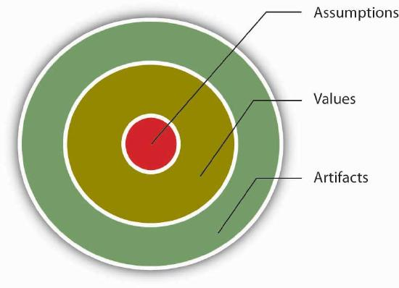Figure 8.5 Three Levels of Organizational Culture Adapted from Schein, E. H. (1992). Organizational Culture and Leadership. San Francisco: Jossey-Bass.
Organizational culture consists of some aspects that are relatively more visible, as well as aspects that may lie below one’s conscious awareness. Organizational culture can be thought of as consisting of three interrelated levels (Schein, 1992).
At the deepest level, below our awareness, lie basic assumptions. These assumptions are taken for granted and reflect beliefs about human nature and reality. At the second level, values exist. Values are shared principles, standards, and goals. Finally, at the surface, we have artifacts, or visible, tangible aspects of organizational culture. For example, in an organization, a basic assumption employees and managers share might be that happy employees benefit their organizations. This might be translated into values such as egalitarianism, high-quality relationships, and having fun. The artifacts reflecting such values might be an executive “open door” policy, an office layout that includes open spaces and gathering areas equipped with pool tables, and frequent company picnics.
Understanding the organization’s culture may start from observing its artifacts: its physical environment, employee interactions, company policies, reward systems, and other observable characteristics. When you are interviewing for a position, observing the physical environment, how people dress, where they relax, and how they talk to others is definitely a good start to understanding the company’s culture. However, simply looking at these tangible aspects is unlikely to give a full picture of the organization, since an important chunk of what makes up culture exists below one’s degree of awareness. The values and, deeper, the assumptions that shape the organization’s culture can be uncovered by observing how employees interact and the choices they make, as well as by inquiring about their beliefs and perceptions regarding what is right and appropriate behavior.

Key Takeaway
Organizational culture is a system of shared assumptions, values, and beliefs that helps individuals understand which behaviors are and are not appropriate within an organization. Cultures can be a source of competitive advantage for organizations. Strong organizational cultures can be an organizing as well as a controlling mechanism for organizations. And finally, organizational culture consists of three levels: assumptions that are below the surface, values, and artifacts.

Exercises
- Why do companies need culture?
- Give an example of a company culture being a strength and a weakness.
- In what ways does culture serve as a controlling mechanism?
- If assumptions are below the surface, why do they matter?
- Share examples of artifacts you have noticed at different organizations.
¹Why culture can mean life or death for your organization. (September, 2007). HR Focus, 84, 9.

8.4: Measuring Organizational Culture

  - 8.3: Understanding Organizational Culture

  - 8.5: Creating and Maintaining Organizational Culture
- picture_as_pdf
Downloads
Buy Print Copy
Review / Adopt
View on CommonsDonate
- Anonymous
- LibreTexts

Learning Objectives
- Understand different dimensions of organizational culture.
- Understand the role of culture strength.
- Explore subcultures within organizations.

Dimensions of Culture
Which values characterize an organization’s culture? Even though culture may not be immediately observable, identifying a set of values that might be used to describe an organization’s culture helps us identify, measure, and manage culture more effectively. For this purpose, several researchers have proposed various culture typologies. One typology that has received a lot of research attention is the Organizational Culture Profile (OCP) where culture is represented by seven distinct values (Chatman & Jehn, 1991; O’Reilly, et. al., 1991).
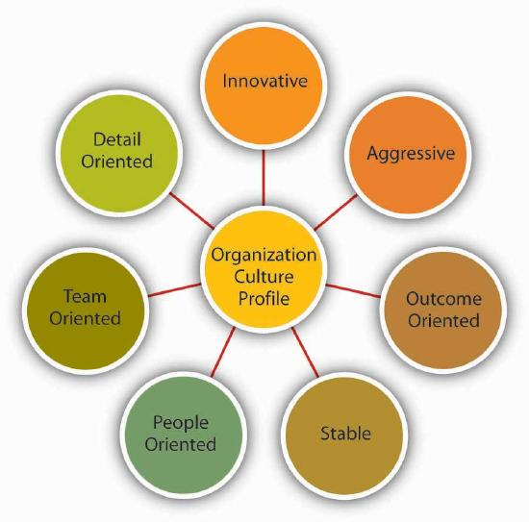Figure 8.4.1: Dimensions of Organizational Culture Profile (OCP) Adapted from information in O’Reilly, C. A., III, Chatman, J. A., & Caldwell, D. F. (1991). People and organizational culture: A profile comparison approach to assessing person-organization fit. Academy of Management Journal, 34, 487–516.

Innovative Cultures
According to the OCP framework, companies that have innovative cultures are flexible, adaptable, and experiment with new ideas. These companies are characterized by a flat hierarchy and titles and other status distinctions tend to be downplayed. For example, W. L. Gore & Associates is a company with innovative products such as GORE-TEX® (the breathable fabric that is windproof and waterproof), Glade dental floss, and Elixir guitar strings, earning the company the distinction as the most innovative company in the United States by Fast Company magazine in 2004. W. L. Gore consistently manages to innovate and capture the majority of market share in a wide variety of industries, in large part because of its unique culture. In this company, employees do not have bosses in the traditional sense, and risk taking is encouraged by celebrating failures as well as successes (Deutschman, 2004). Companies such as W. L. Gore, Genentech, and Google also encourage their employees to take risks by allowing engineers to devote 20% of their time to projects of their own choosing.

Aggressive Cultures
Companies with aggressive cultures value competitiveness and outperforming competitors; by emphasizing this, they often fall short in corporate social responsibility. For example, Microsoft is often identified as a company with an aggressive culture. The company has faced a number of antitrust lawsuits and disputes with competitors over the years. In aggressive companies, people may use language such as “we will kill our competition.” In the past, Microsoft executives made statements such as “we are going to cut off Netscape’s air supply…Everything they are selling, we are going to give away,” and its aggressive culture is cited as a reason for getting into new legal troubles before old ones are resolved (Greene, et. al., 2004; Schlender, 1998).
Figure 8.4.2: Microsoft, the company that Bill Gates co-founded, has been described as having an aggressive culture. IsaacMao – Bill Gates world’s most “spammed” person – CC BY 2.0.

Outcome-Oriented Cultures
The OCP framework describes outcome-oriented cultures as those that emphasize achievement, results, and action as important values. A good example of an outcome-oriented culture may be the electronics retailer Best Buy. Having a culture emphasizing sales performance, Best Buy tallies revenues and other relevant figures daily by department. Employees are trained and mentored to sell company products effectively, and they learn how much money their department made every day (Copeland, 2004). In 2005, the company implemented a Results Oriented Work Environment (ROWE) program that allows employees to work anywhere and anytime; they are evaluated based on results and fulfillment of clearly outlined objectives (Thompson, 2005). Outcome-oriented cultures hold employees as well as managers accountable for success and use systems that reward employee and group output. In these companies, it is more common to see rewards tied to performance indicators as opposed to seniority or loyalty. Research indicates that organizations that have a performance-oriented culture tend to outperform companies that are lacking such a culture (Nohria, et. al., 2003). At the same time, when performance pressures lead to a culture where unethical behaviors become the norm, individuals see their peers as rivals, and short-term results are rewarded, the resulting unhealthy work environment serves as a liability (Probst & Raisch, 2005).

Stable Cultures
Stable cultures are predictable, rule-oriented, and bureaucratic. When the environment is stable and certain, these cultures may help the organization to be effective by providing stable and constant levels of output (Westrum, 2004). These cultures prevent quick action and, as a result, may be a misfit to a changing and dynamic environment. Public sector institutions may be viewed as stable cultures. In the private sector, Kraft Foods is an example of a company with centralized decision making and rule orientation that suffered as a result of the culture-environment mismatch (Thompson, 2006). Its bureaucratic culture is blamed for killing good ideas in early stages and preventing the company from innovating. When the company started a change program to increase the agility of its culture, one of its first actions was to fight bureaucracy with more bureaucracy: The new position of vice president of “business process simplification” was created but was later eliminated (Boyle, 2004; Thompson, 2005; Thompson, 2006).

People-Oriented Cultures
People-oriented cultures value fairness, supportiveness, and respecting individual rights. In these organizations, there is a greater emphasis on and expectation of treating people with respect and dignity (Erdogan, et. al., 2006). One study of new employees in accounting companies found that employees, on average, stayed 14 months longer in companies with people-oriented cultures (Sheridan, 1992). Starbucks is an example of a people-oriented culture. The company pays employees above minimum wage, offers health care and tuition reimbursement benefits to its part-time as well as full-time employees, and has creative perks such as weekly free coffee for all associates. As a result of these policies, the company benefits from a turnover rate lower than the industry average (Weber, 2005).

Team-Oriented Cultures
Companies with a team-oriented culture are collaborative and emphasize cooperation among employees. For example, Southwest Airlines facilitates a team-oriented culture by cross-training its employees so that they are capable of helping one another when needed. The company also emphasizes training intact work teams (Bolino & Turnley, 2003). In Southwest’s selection process, applicants who are not viewed as team players are not hired as employees (Miles & Mangold, 2005). In team-oriented organizations, members tend to have more positive relationships with their coworkers and particularly with their managers (Erdogan, et. al., 2006).
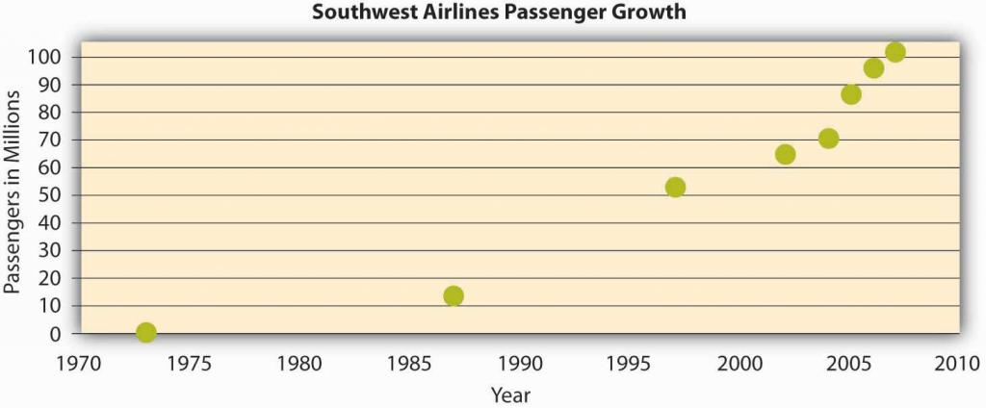Figure 8.4.3: The growth in the number of passengers flying with Southwest Airlines from 1973 until 2007 when Southwest surpassed American Airlines as the most flown U.S. airline. While price has played a role in this, their emphasis on service has been a key piece of their culture and competitive advantage. Adapted from upload.wikimedia.org/Wikipedia/commons/6/69/Southwest-airlines-passengers.jpg

Detail-Oriented Cultures
Figure 8.4.4: Remember that, in the end, culture is really about people. Chris Jones – Culture in the UK – CC BY-NC 2.0
Organizations with a detail-oriented culture are characterized in the OCP framework as emphasizing precision and paying attention to details. Such a culture gives a competitive advantage to companies in the hospitality industry by helping them differentiate themselves from others. For example, Four Seasons and Ritz Carlton are among hotels who keep records of all customer requests such as which newspaper the guest prefers or what type of pillow the customer uses. This information is put into a computer system and used to provide better service to returning customers. Any requests hotel employees receive, as well as overhear, might be entered into the database to serve customers better.

Strength of Culture
A strong culture is one that is shared by organizational members (Arogyaswamy & Byles, 1987; Chatman & Eunyoung, 2003)).—that is, a culture in which most employees in the organization show consensus regarding the values of the company. The stronger a company’s culture, the more likely it is to affect the way employees think and behave. For example, cultural values emphasizing customer service will lead to higher-quality customer service if there is widespread agreement among employees on the importance of customer-service-related values (Schneider, et. al., 2002).
It is important to realize that a strong culture may act as an asset or a liability for the organization, depending on the types of values that are shared. For example, imagine a company with a culture that is strongly outcome-oriented. If this value system matches the organizational environment, the company may perform well and outperform its competitors. This is an asset as long as members are behaving ethically. However, a strong outcome-oriented culture coupled with unethical behaviors and an obsession with quantitative performance indicators may be detrimental to an organization’s effectiveness. Enron is an extreme example of this dysfunctional type of strong culture.
One limitation of a strong culture is the difficulty of changing it. In an organization where certain values are widely shared, if the organization decides to adopt a different set of values, unlearning the old values and learning the new ones will be a challenge because employees will need to adopt new ways of thinking, behaving, and responding to critical events. For example, Home Depot had a decentralized, autonomous culture where many business decisions were made using “gut feeling” while ignoring the available data. When Robert Nardelli became CEO of the company in 2000, he decided to change its culture starting with centralizing many of the decisions that were previously left to individual stores. This initiative met with substantial resistance, and many high-level employees left during Nardelli’s first year. Despite getting financial results such as doubling the sales of the company, many of the changes he made were criticized. He left the company in January 2007 (Charan, 2006; Herman & Wernle, 2007).
Figure 8.4.5: Walt Disney created a strong culture at his company that has evolved since its founding in 1923. NASA – Walt disney portrait – public domain
A strong culture may also be a liability during a merger. During mergers and acquisitions, companies inevitably experience a clash of cultures, as well as a clash of structures and operating systems. Culture clash becomes more problematic if both parties have unique and strong cultures. For example, during the merger of Daimler-Benz with Chrysler to create DaimlerChrysler, the differing strong cultures of each company acted as a barrier to effective integration. Daimler had a strong engineering culture that was more hierarchical and emphasized routinely working long hours. Daimler employees were used to being part of an elite organization, evidenced by flying first class on all business trips. However, Chrysler had a sales culture where employees and managers were used to autonomy, working shorter hours, and adhering to budget limits that meant only the elite flew first class. The different ways of thinking and behaving in these two companies introduced a number of unanticipated problems during the integration process (Badrtalei & Bates, 2007; Bower, 2001)

Do Organizations Have a Single Culture?
So far, we have assumed that a company has a single culture that is shared throughout the organization. In reality there might be multiple cultures within the organization. For example, people working on the sales floor may experience a different culture from that experienced by people working in the warehouse. Cultures that emerge within different departments, branches, or geographic locations are called subcultures. Subcultures may arise from the personal characteristics of employees and managers, as well as the different conditions under which work is performed. In addition to understanding the broader organization’s values, managers will need to make an effort to understand subculture values to see their effect on workforce behavior and attitudes.
Sometimes, a subculture may take the form of a counterculture. Defined as shared values and beliefs that are in direct opposition to the values of the broader organizational culture (Kerr, et. al., 2005), countercultures are often shaped around a charismatic leader. For example, within a largely bureaucratic organization, an enclave of innovativeness and risk taking may emerge within a single department. A counterculture may be tolerated by the organization as long as it is bringing in results and contributing positively to the effectiveness of the organization. However, its existence may be perceived as a threat to the broader organizational culture. In some cases, this may lead to actions that would take away the autonomy of the managers and eliminate the counterculture.

Key Takeaway
Culture can be understood in terms of seven different culture dimensions, depending on what is most emphasized within the organization. For example, innovative cultures are flexible, adaptable, and experiment with new ideas, while stable cultures are predictable, rule-oriented, and bureaucratic. Strong cultures can be an asset or liability for an organization but can be challenging to change. Multiple cultures may coexist in a single organization in the form of subcultures and countercultures.

Exercises
- Think about an organization you are familiar with. On the basis of the dimensions of OCP, how would you characterize its culture?
- Out of the culture dimensions described, which dimension do you think would lead to higher levels of employee satisfaction and retention? Which one would be related to company performance?
- What are pros and cons of an outcome-oriented culture?
- When bureaucracies were first invented, they were considered quite innovative. Do you think that different cultures are more or less effective at different points in time and in different industries? Why or why not?
- Can you imagine an effective use of subcultures within an organization?

8.6: Creating Culture Change

  - 8.5: Creating and Maintaining Organizational Culture

  - 8.7: Developing Your Personal Skills: Learning to Fit In
- picture_as_pdf
Downloads
Buy Print Copy
Review / Adopt
View on CommonsDonate
- Anonymous
- LibreTexts

Learning Objectives
- Understand the process of culture change.

How Do Cultures Change?
As emphasized throughout this chapter, culture is a product of its founder’s values, its history, and collective experiences. Hence, culture is part of a company’s DNA and is resistant to change efforts. Unfortunately, many organizations realize that their current culture constitutes a barrier against organizational productivity and performance. Particularly when there is a mismatch between an organization’s values and the demands of its environment, changing the culture becomes the key to the company turnaround.
Achieving culture change is challenging, and there are many companies that ultimately fail in this mission. Research and case studies of companies that successfully changed their culture indicate that the following six steps increase the chances of success (Schein, 1990).
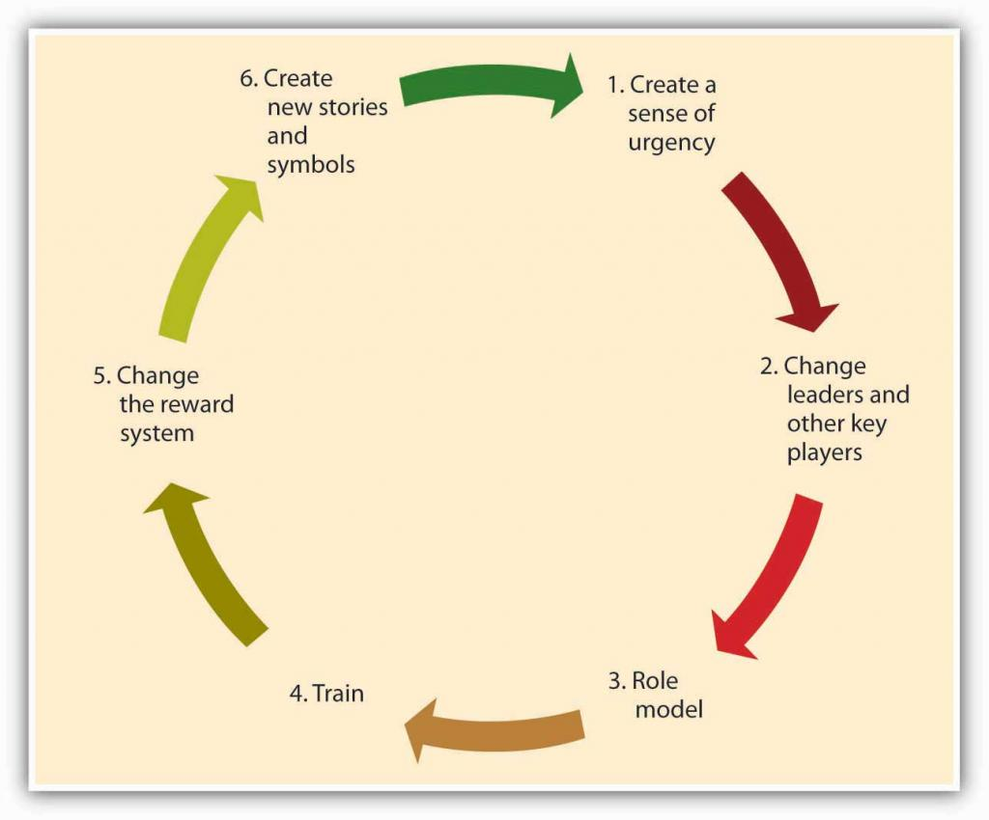Figure 8.6.1: Process of Culture Change

Creating a Sense of Urgency
For the change effort to be successful, it is important to communicate the need for change to employees. One way of doing this is to create a sense of urgency on the part of employees, explaining to them why changing the fundamental way in which business is done is so important. In successful culture change efforts, leaders communicate with employees and present a case for culture change as the essential element that will lead the company to eventual success. As an example, consider the situation at IBM in 1993 when Lou Gerstner was brought in as CEO and chairman. After decades of dominating the market for mainframe computers, IBM was rapidly losing market share to competitors, and its efforts to sell personal computers—the original PC—were seriously undercut by cheaper “clones.” In the public’s estimation, the name IBM had become associated with obsolescence. Gerstner recalls that the crisis IBM was facing became his ally in changing the organization’s culture. Instead of spreading optimism about the company’s future, he used the crisis at every opportunity to get buy-in from employees (Gerstner, 2002).

Changing Leaders and Other Key Players
A leader’s vision is an important factor that influences how things are done in an organization. Thus, culture change often follows changes at the highest levels of the organization. Moreover, to implement the change effort quickly and efficiently, a company may find it helpful to remove managers and other powerful employees who are acting as a barrier to change. Because of political reasons, self-interest, or habits, managers may create powerful resistance to change efforts. In such cases, replacing these positions with employees and managers giving visible support to the change effort may increase the likelihood that the change effort succeeds. For example, when Robert Iger replaced Michael Eisner as CEO of the Walt Disney Company, one of the first things he did was to abolish the central planning unit, which was staffed by people close to ex-CEO Eisner. This department was viewed as a barrier to creativity at Disney and its removal from the company was helpful in ensuring the innovativeness of the company culture (McGregor, et. al., 2007).

Role Modeling
Role modeling is the process by which employees modify their own beliefs and behaviors to reflect those of the leader (Kark & Van Dijk, 2007). CEOs can model the behaviors that are expected of employees to change the culture because these behaviors will trickle down to lower-level employees. For example, when Robert Iger took over Disney, to show his commitment to innovation, he personally became involved in the process of game creation, attended summits of developers, and gave feedback to programmers about the games. Thus, he modeled his engagement in the idea creation process. In contrast, the modeling of inappropriate behavior from the top will lead to the same behavior trickling down to lower levels. A recent example to this type of role modeling is the scandal involving Hewlett-Packard board members. In 2006, when board members were suspected of leaking confidential company information to the press, the company’s top-level executives hired a team of security experts to find the source of the leak. The investigators sought the phone records of board members, looking for links to journalists. For this purpose, they posed as board members and called phone companies to obtain itemized home phone records of board members and journalists. When the investigators’ methods came to light, HP’s chairman and four other top executives faced criminal and civil charges. When such behavior is modeled at top levels, it is likely to have an adverse effect on the company culture (Barron, 2007).

Training
Well-crafted training programs may be instrumental in bringing about culture change by teaching employees the new norms and behavioral styles. For example, after the space shuttle Columbia disintegrated on reentry from a February 2003 mission, NASA decided to change its culture to become more safety sensitive and minimize decision-making errors that lead to unsafe behaviors. The change effort included training programs in team processes and cognitive bias awareness. Similarly, when auto repairer Midas felt the need to change its culture to be more committed to customers, they developed a program to train employees to be more familiar with customer emotions and connect better with them. Customer reports have been overwhelmingly positive in stores that underwent this training.¹

Changing the Reward System
The criteria with which employees are rewarded and punished have a powerful role in determining the cultural values of an organization. Switching from a commission-based incentive structure to a straight salary system may be instrumental in bringing about customer focus among sales employees. Moreover, by rewarding and promoting employees who embrace the company’s new values and promoting these employees, organizations can make sure that changes in culture have a lasting effect. If the company wants to develop a team-oriented culture where employees collaborate with one another, then using individual-based incentives may backfire. Instead, distributing bonuses to intact teams might be more successful in bringing about culture change.

Creating New Symbols and Stories
Finally, the success of the culture change effort may be increased by developing new rituals, symbols, and stories. Continental Airlines is a company that successfully changed its culture to be less bureaucratic and more team-oriented in 1990s. One of the first things management did to show employees that they really meant to abolish many of the company’s detailed procedures and create a culture of empowerment was to burn the heavy 800-page company policy manual in their parking lot. The new manual was only 80 pages. This action symbolized the upcoming changes in the culture and served as a powerful story that circulated among employees. Another early action was redecorating waiting areas and repainting all their planes, again symbolizing the new order of things (Higgins & McAllester, 2004). By replacing the old symbols and stories, the new symbols and stories will help enable the culture change and ensure that the new values are communicated.

Key Takeaway
Organizations need to change their culture to respond to changing conditions in the environment, to remain competitive, and to avoid complacency or stagnation. Culture change often begins by the creation of a sense of urgency. Next, a change of leaders and other key players may enact change and serve as effective role models of new behavior. Training can also be targeted toward fostering these new behaviors. Reward systems are changed within the organization. Finally, the organization creates new stories and symbols. Successful culture change requires managers that are proficient at all of the P-O-L-C functions. Creating and communicating a vision is part of planning; leadership and role modeling are part of leading; designing effective reward systems is part of controlling; all of which combine to influence culture, a facet of organizing.

Exercises
- Can new employees change a company’s culture? If so, how?
- Are there any conditions under which change is not possible? If so, what would such conditions be?
- Have you ever observed a change process at an organization you were involved with? If so, what worked well and what didn’t?
- What recommendations would you have for someone considering a major change of culture within their own organization?

8.7: Developing Your Personal Skills: Learning to Fit In

  - 8.6: Creating Culture Change

  - 9: Social Networks
- picture_as_pdf
Downloads
Buy Print Copy
Review / Adopt
View on CommonsDonate
- Anonymous
- LibreTexts

Learning Objectives
- Understand what you can proactively do to understand a new organizational environment.
- Some guidelines for proactive onboarding.

Before You Join
How do you find out about a company’s culture before you join? Here are several tips that will allow you to more accurately gauge the culture of a company you are interviewing with.
First, do your research. Talking to friends and family members who are familiar with the company, doing an online search for news articles about the company, browsing the company’s Web site, and reading its mission statement would be a good start.
Second, observe the physical environment. Do people work in cubicles or in offices? What is the dress code? What is the building structure? Do employees look happy, tired, or stressed? The answers to these questions are all pieces of the puzzle.
Third, read between the lines. For example, the absence of a lengthy employee handbook or detailed procedures might mean that the company is more flexible and less bureaucratic.
Fourth, reflect on how you are treated. The recruitment process is your first connection to the company. Were you treated with respect? Do they maintain contact with you or are you being ignored for long stretches at a time?
Fifth, ask questions. What happened to the previous incumbent of this job? What does it take to be successful in this firm? What would their ideal candidate for the job look like? The answers to these questions will reveal a lot about the way they do business.
Finally, listen to your gut. Your feelings about the place in general, and your future manager and coworkers in particular, are important signs that you should not ignore (Daniel & Brandon, 2006; Sacks, 2005).

You’ve Got a New Job! Now How Do You Get on Board?
- Gather information. Try to find as much about the company and the job as you can before your first day. After you start working, be a good observer, gather information, and read as much as you can to understand your job and the company. Examine how people are interacting, how they dress, and how they act, in order to avoid behaviors that might indicate to others that you are a misfit.
- Manage your first impression. First impressions may endure, so make sure that you dress properly, are friendly, and communicate your excitement to be a part of the team. Be on your best behavior!
- Invest in relationship development. The relationships you develop with your manager and with coworkers will be essential for you to adjust to your new job. Take the time to strike up conversations with them. If there are work functions during your early days, make sure not to miss them!
- Seek feedback. Ask your manager or coworkers how well you are doing and whether you are meeting expectations. Listen to what they are telling you and listen to what they are not saying. Then, make sure to act on any suggestions for improvement—you may create a negative impression if you consistently ignore the feedback you receive.
- Show success early on. To gain the trust of your new manager and colleagues, you may want to establish a history of success early. Volunteer for high-profile projects where you will be able to demonstrate your skills. Alternatively, volunteer for projects that may serve as learning opportunities or that may put you in touch with the key people in the company.

Key Takeaway
There are a number of ways to learn about an organization’s culture before you formally join it. Take the time to consider whether the culture you are observing seems like the right fit for you. Once you get a job, you can do key things to maximize your onboarding success.

Exercises
- What clues does your college or school give about its culture?
- What are four things you could do today to learn more about an organization you are interested in?
- Imagine that your good friend is starting a new job next week. What recommendations would you give your friend to help him or her do a great job onboarding into the organization?

